Homework 9 – VM’s and VMSS; Az-104 Lab 08 (screenshots from every last step of all tasks)

Task 1: Deploy zone-resilient Azure virtual machines by using the Azure portal and an Azure Resource Manager template

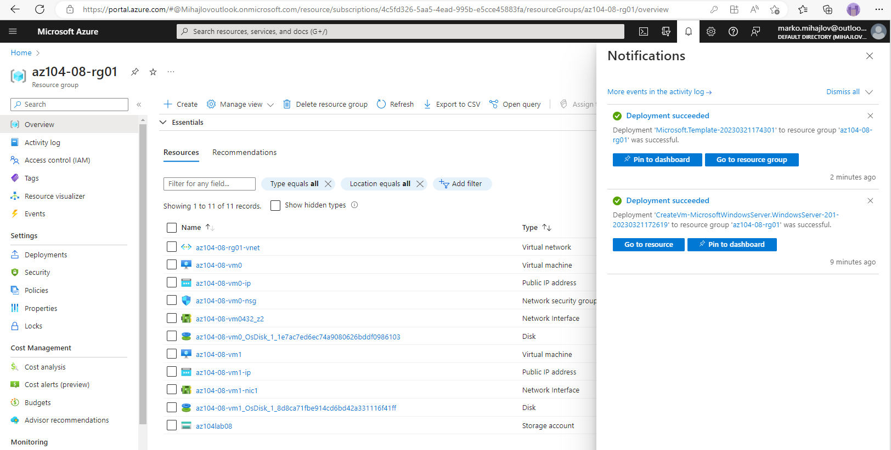

The resources in resource group az104-08-rg01 after deploying the 2 VM’s in differing Availability Zones within same Region from task 1.

Task 2: Configure Azure virtual machines by using virtual machine extensions

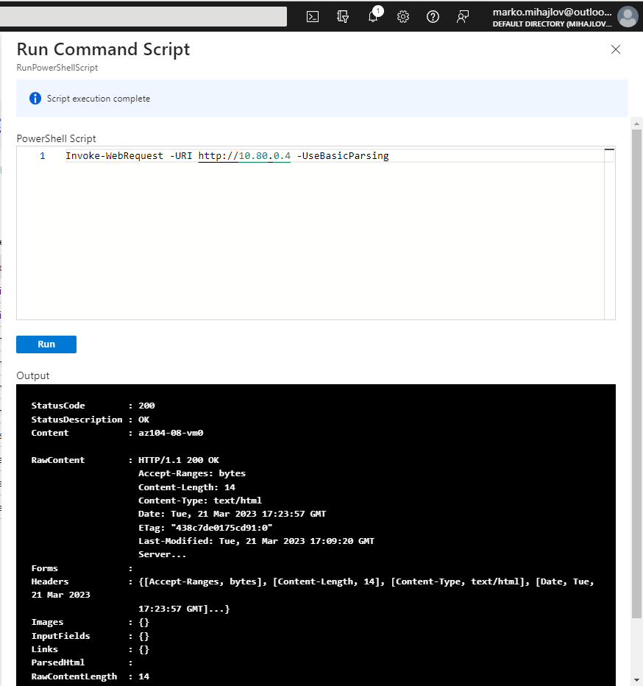

Accessing the website on az104-08-vm0 from az104-08-vm1. (Note that az-104-08-vm0 is the one configured with the imported script).

Task 2: Configure Azure virtual machines by using virtual machine extensions

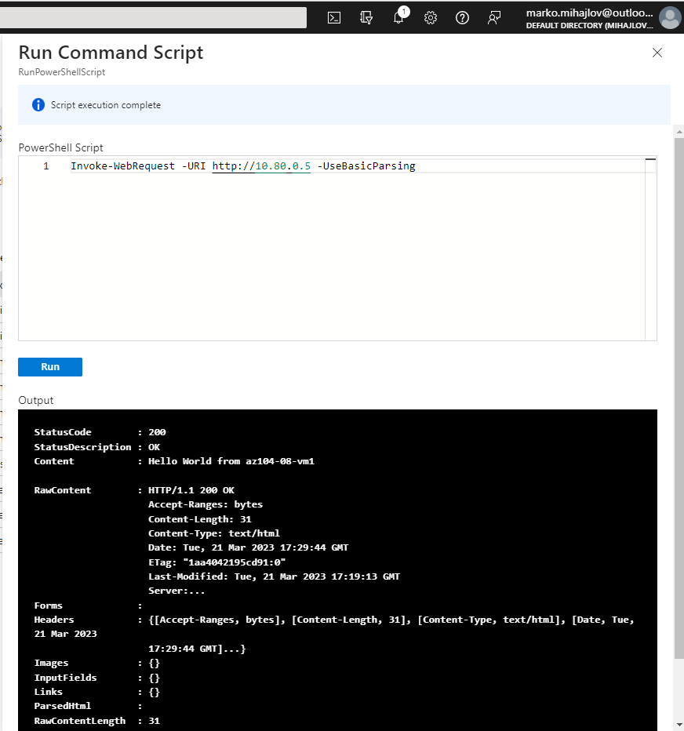

Accessing the website on az104-08-vm1 from az104-08-vm0 (the other end). (Note that az-104-08-vm1 is the one configured from the edited template where we inserted the same code that the script does).

Task 3: Scale compute and storage for Azure virtual machines

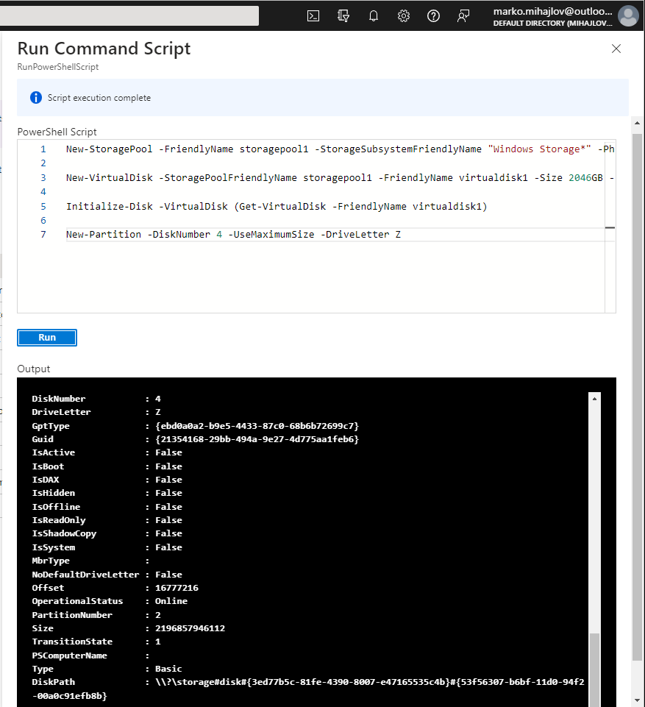

Output after running the Power shell code on az104-08-vm1 to create a drive Z: consisting of the two newly attached disks with the simple layout and fixed provisioning. (same process as for az104-08-vm0) – the VM size and disk modifications were different, via Azure GUI and editing the deployment template for az104-08-vm0 and az104-08-vm1 respectively.

#### Task 4: Register the Microsoft.Insights and Microsoft.AlertsManagement resource providers

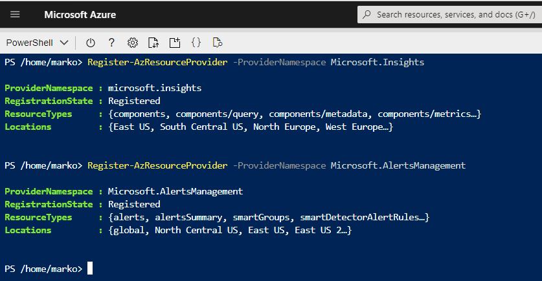

#### Task 5: Deploy zone-resilient Azure virtual machine scale sets by using the Azure portal

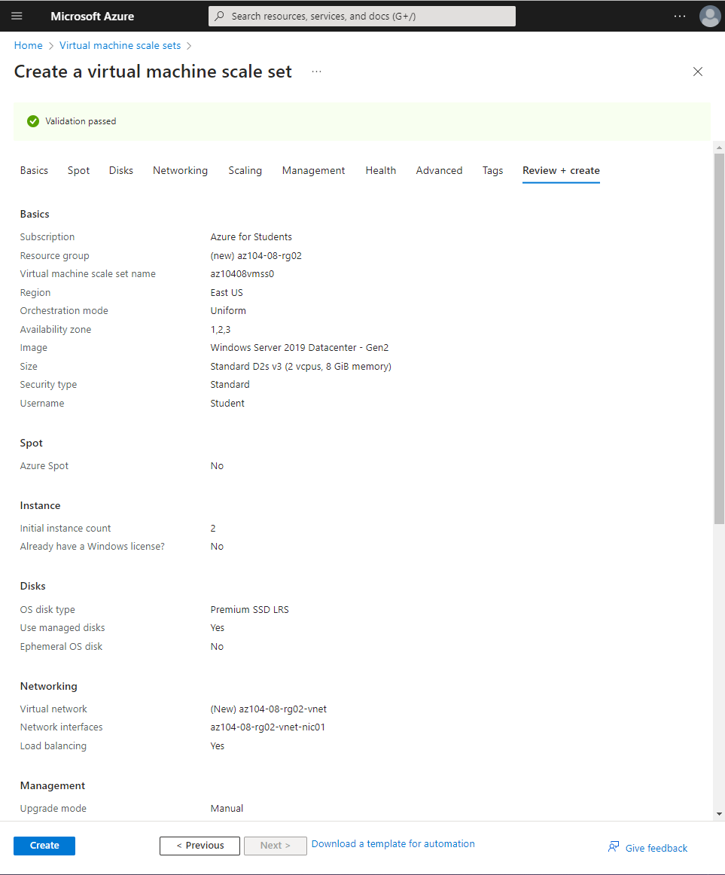

Last page of the VMSS configuration with the parameters listed.

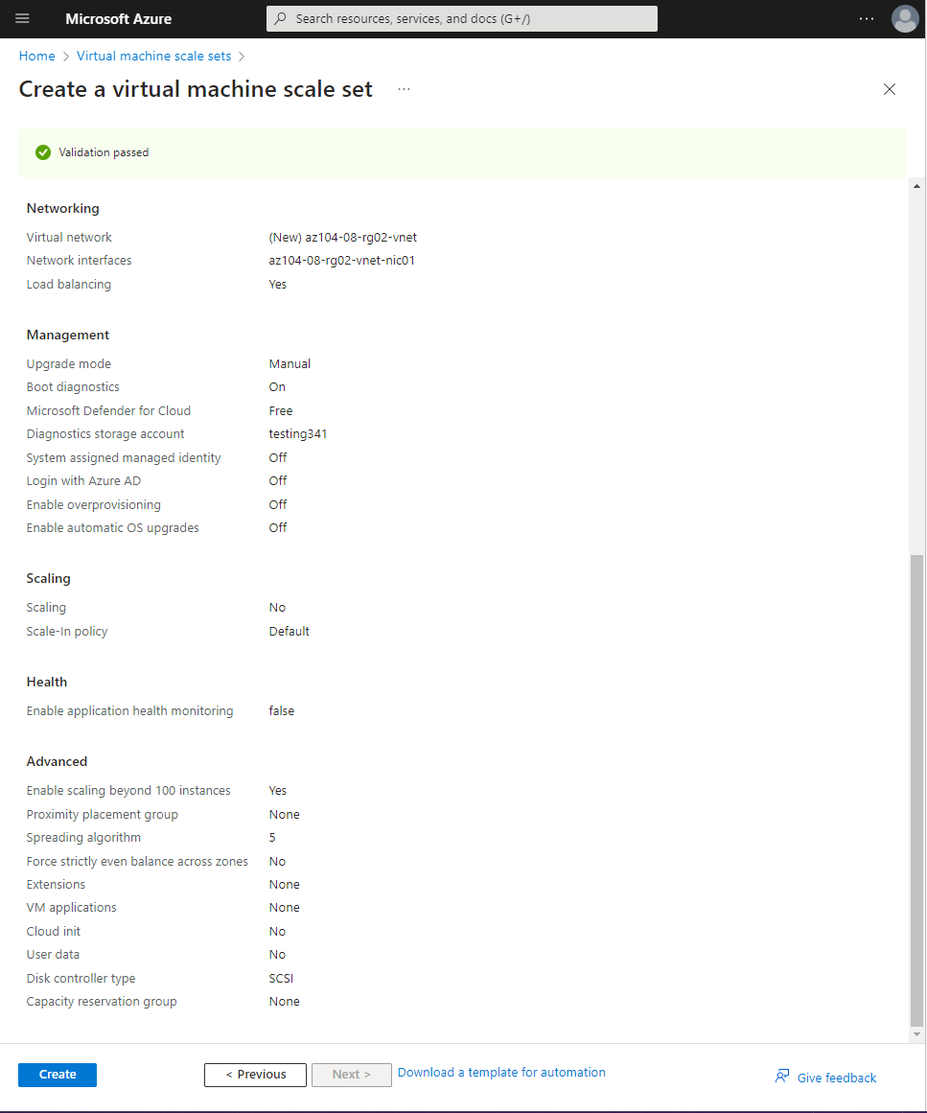

Last page of the VMSS configuration with the parameters listed.

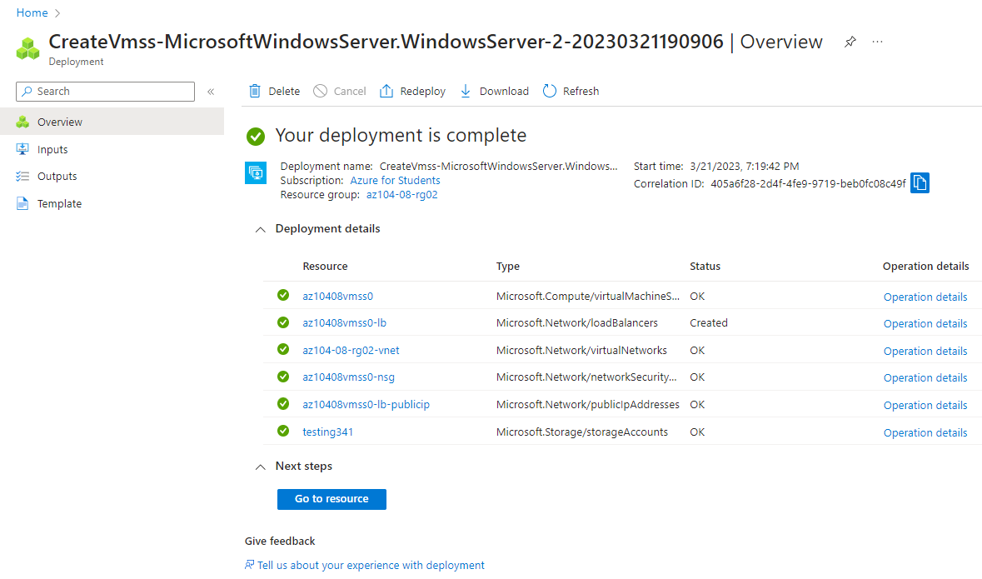

Resulting recources from the VMSS deployment.

#### Task 6: Configure Azure virtual machine scale sets by using virtual machine extensions

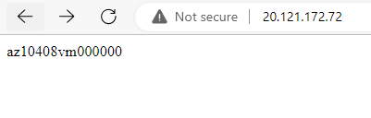

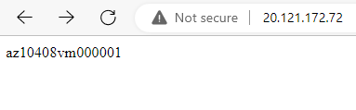

After installation of Internet Information services on the VMSS and applying the new config on the 2 current instances we are opening a new tab with the public IP of the Load balancer which depending on traffic redirects new requests to one or the other VM.

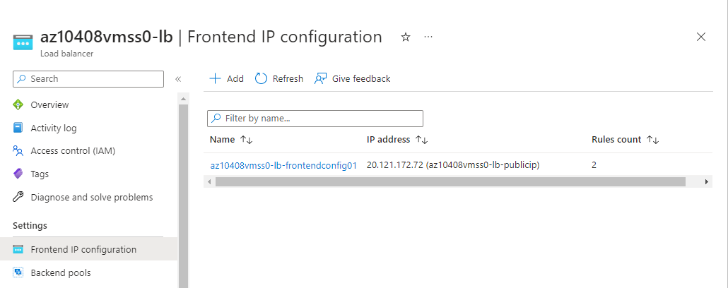

Frontend IP required for the last steo can be seen in this blade on the load balancer.

#### Task 7: Scale compute and storage for Azure virtual machine scale sets

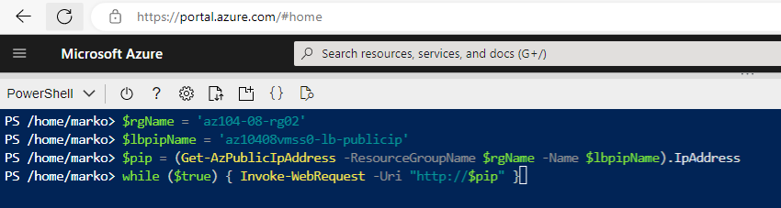

After configuring the custom autoscaling to be triggered from our pings. We are proceeding to input the power shell code for that purpose so our third VM can be created after triggering the custom autoscaling rule. (Please note that the code from the lab had an issue. THE value $lbpipName = 'az10408vmss0-ip' is not correct the correct name can be seen in the pictures above and below from the resources inside the resource group 🡪 ‘az10408vmss0-lb-publicup’ (the public IP of the load balancer is needed).  
Additional note: every one of the 3 VM’s are in a different Availability Zone in the same Region as selected previously while creating the VMSS.

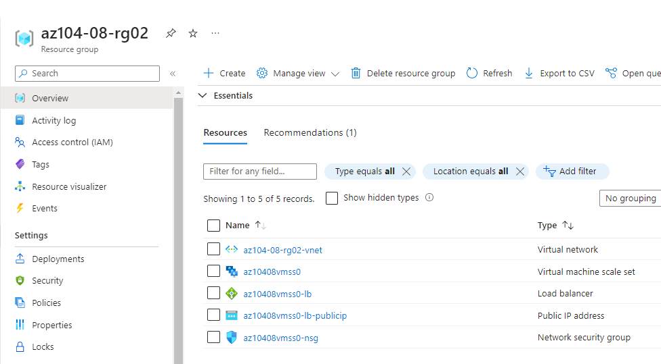

Listed resources in the 2nd resource group created for the exercise including the load balancer IP address resource in question.

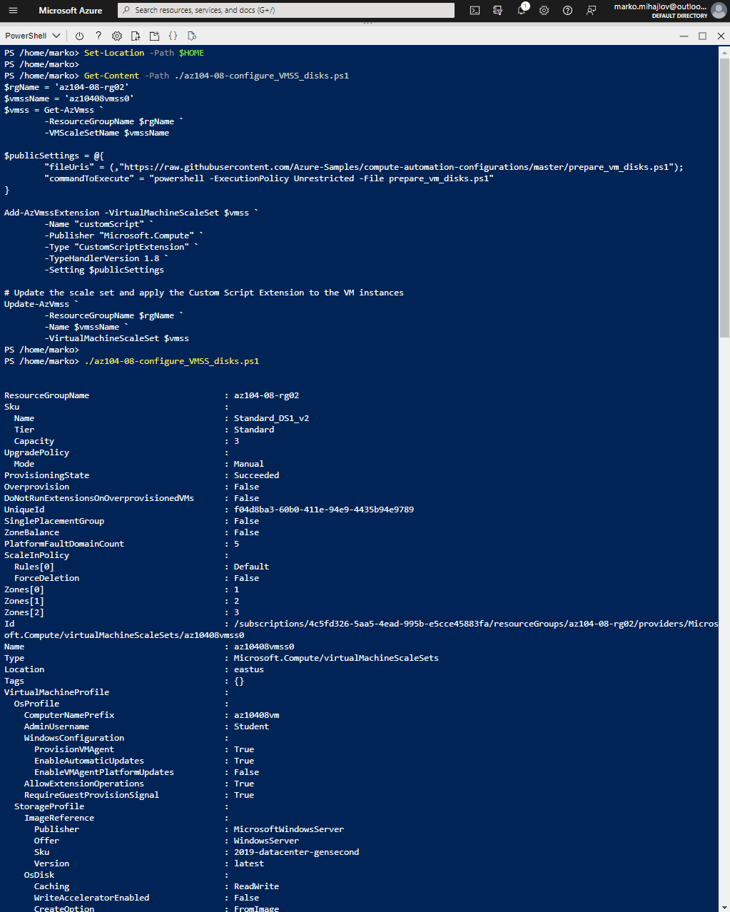

Output of the script - ./az104-08-configure_VMSS_disks.ps1 1/3 which configures the raw disk previously added to the configuration so it can be used. After this step we are adding the change to all of the 3 instances at once by “Upgrading” the selected VM’s

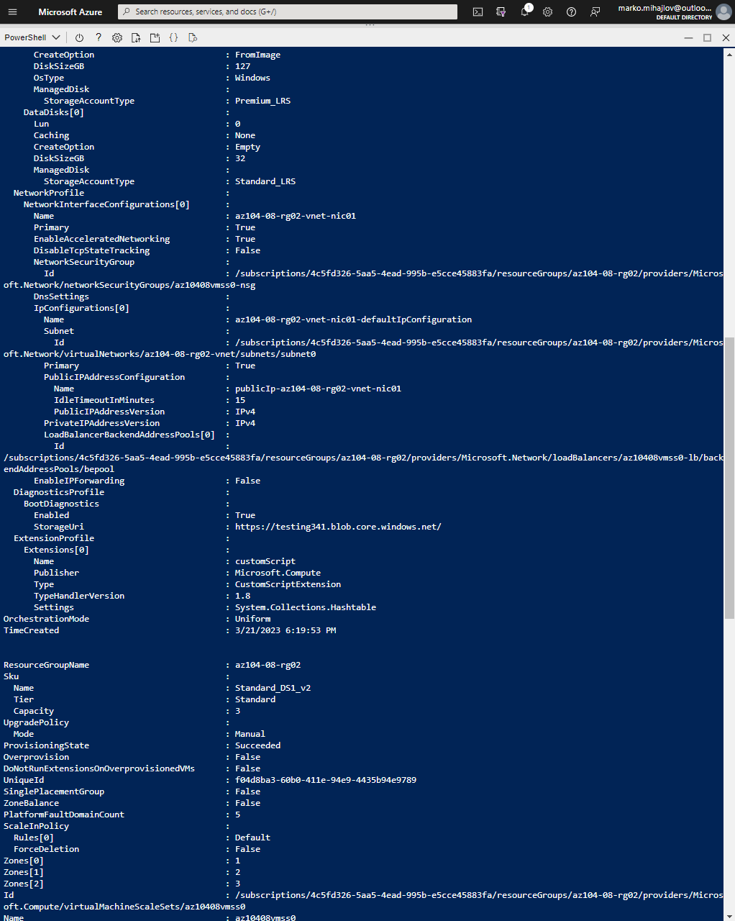

Output of the script - ./az104-08-configure_VMSS_disks.ps1 2/3 which configures the raw disk previously added to the configuration so it can be used. After this step we are adding the change to all of the 3 instances at once by “Upgrading” the selected VM’s

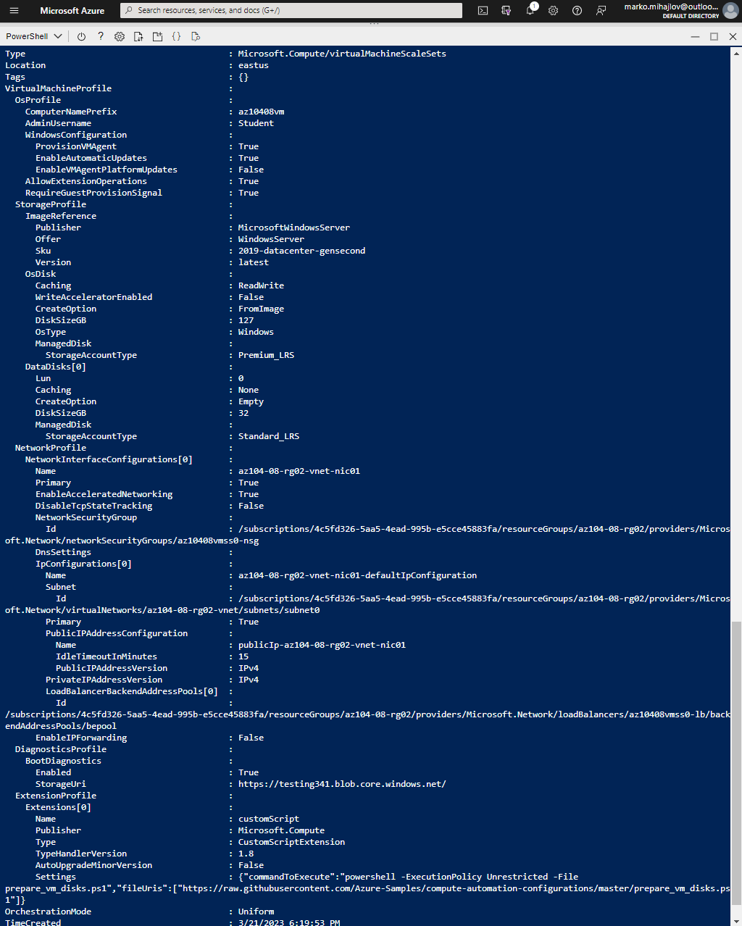

Output of the script - ./az104-08-configure_VMSS_disks.ps1 3/3 which configures the raw disk previously added to the configuration so it can be used. After this step we are adding the change to all of the 3 instances at once by “Upgrading” the selected VM’s

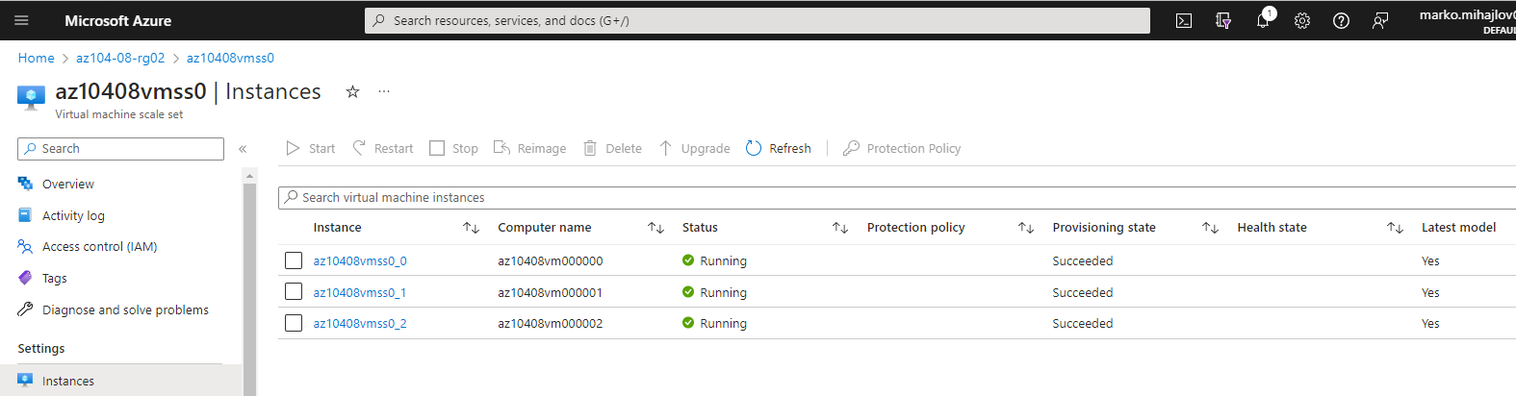

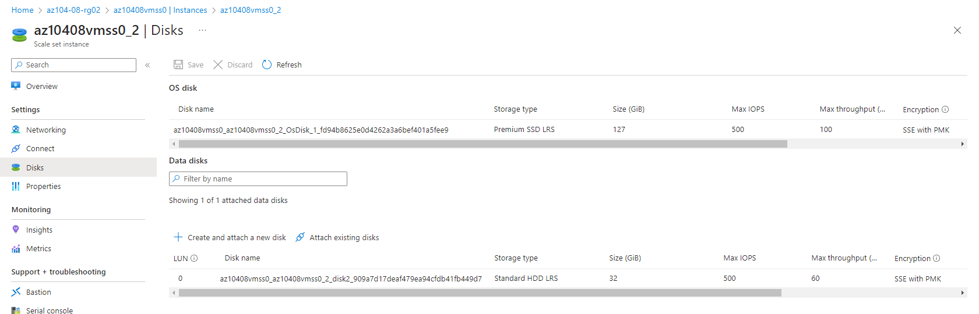

------------------------------------------------------------------------------------------------------------------------------------------

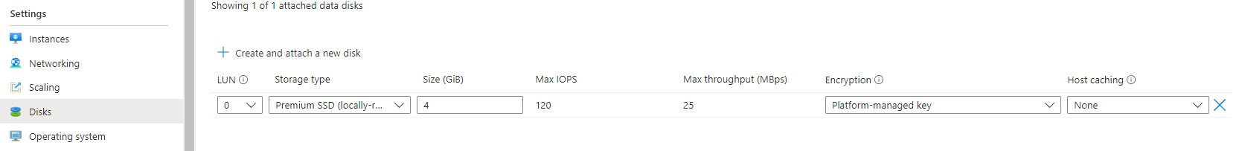

Screenshots depicting how the disk info at one of the VM’s looks after configuration (1) and before configuration when being added to the VMSS In whole (2).